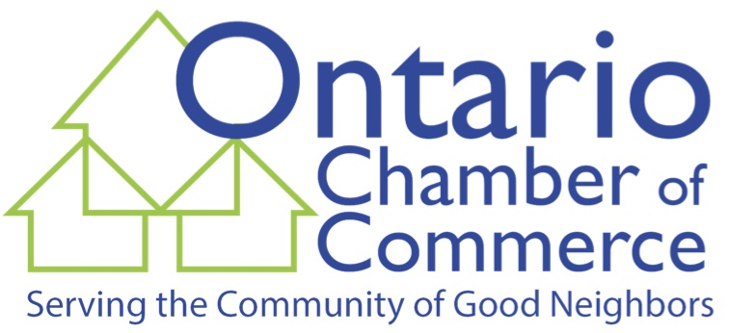 Ontario Chamber of Commerce &
Town of Ontario Parks & Recreation Dept.
Community Nominations Form – 2023
Please check the appropriate category and describe briefly why you feel your nominee is deserving of the selected award. Nominees Do Not Need to Be Chamber Members.

_________Volunteer of the Year: Please describe how this individual has volunteered their time and/or talent to help their neighbors and fellow residents or businesses and civic organizations.

Name & Description: ……………………………………………………………………………………………………………………………………………………………………………………………………………………………………………………………………………………………………………………………………………………………………………………………………………………………………………………………………………………………………………………………………
…………………………………………………………………………………………………………………………………………………………………………

__________Community Organization of the Year: Please describe the contributions this non-profit organization has made to improve the quality of life of Ontario residents.

Name & Description: ……………………………………………………………………………………………………………………………………………………………………………………………………………………………………………………………………………………………………………………………………………………………………………………………………………………………………………………………………………………………………………………………………
…………………………………………………………………………………………………………………………………………………………………………

__________Business Improvement Award: Please describe what improvements have been made to the business. This could be in building renovations; expansion; added employees; new product line(s); façade and landscaping improvements; and/or outstanding achievements in their field of business.

Name & Description: ………………………………………………………………………………………………………………………………………………………………………………………………………………………………………………………………………………………………………………………………………………………………………………………………………………………………………………………………………………………………………………………………………
……………………………………………………………………………………………………………………………………………………………………………

Please send this form to the Ontario Chamber of Commerce, PO Box 100, Ontario, NY 14519-0100 or email your nomination and description to: Donna Burolla, President, Ontario Chamber (dburolla@gmail.com).
NOMINATION DEADLINE: June 30, 2023
Winners will be announced at the Ontario Chamber’s Annual Award & Recognition Banquet
Sponsored With the Town of Ontario Parks & Recreation Department
September 21, 2023 at The Ontario Golf Club, Pub On The Green

